Boyer-Moore

* Scan characters in pattern from right to left
* Can skip as many as M text chars when finding one not in the pattern

How much do we skip? See below

**Case 1:** mismatch character not in pattern

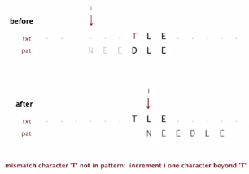

Increment i one character beyond the character you were looking at

**Case 2a**: mismatch character in pattern

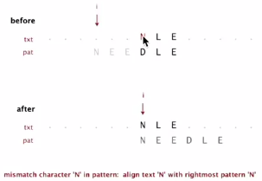

Align with pointer with rightmost character of the pattern UNLESS:

**Case 2b**: mismatch character in pattern (but heuristic is no help)

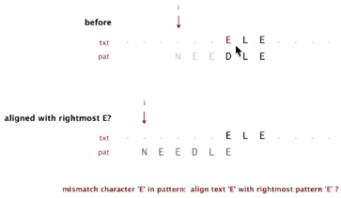

Simply increment i by 1

So how much do we skip?

A: Precompute index of rightmost occurrence of character c in pattern (-1 if character not in pattern)

Precomputation implementation

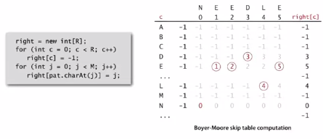

Boyer-Moore implementation in Java

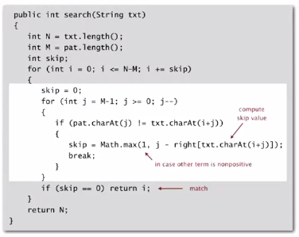

Property: Substring search with the Boyer-Moore mismatched character heuristic takes about ~N / M character compares to search for a pattern of length M in a text of length N… that’s sublinear!!

Worst case: can be as bad ~M N :

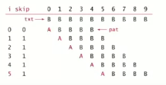

Solution to improve worst case: improve to ~3N worst case by adding a KMP rule to guard against repetitive patterns.